Containers vs. Virtual Machines for Web Applications: Midterm Report
SENG 533, Group 9: Adrian Co, Ahron Ramos, Aaron Montesines, Nathan Mangold · November 6, 2026

Abstract
We compare a database-backed web application (WordPress 6.9.11 with MariaDB) on Cybera's Rapid Access Cloud when it runs natively on a VM and when it runs in a single Docker container on the same VM. This midterm report covers a pilot of 18 runs: two deployments, 10, 25 and 50 concurrent users, and three repetitions each, with a read-only browsing workload generated by k6. Above 10 users the web VM was the limiting component in both deployments: its CPU reached about 96–98% at 25 users and about 99.6–99.9% at 50, while throughput levelled off at roughly 15–17 successful HTTP requests/s and p95 response time rose from about 0.3–0.4 s to between 1.3 and 6.0 s. The database and load-generator VMs stayed below 9% CPU (95th percentile of 1-second samples), so neither limited the results. No HTTP failures or failed application checks occurred in any run. Native WordPress had lower p95 latency than the single container in every repetition at every load level, but the 95% confidence intervals overlap, so we report this as a preliminary observation and make no claim of a clear winner or of maximum capacity. The multi-container configuration, scaling experiments, startup-time trials and write workloads have not been run yet and are planned.

1. Introduction
Containers promise lower overhead and faster start-up than virtual machines, but most published comparisons use microbenchmarks rather than a complete multi-tier web application under increasing user load. Our project measures a realistic WordPress deployment so that the deployment layer is the only independent variable. This report presents what has been completed so far (infrastructure, workload, monitoring and an 18-run pilot), the preliminary results, their limits, how the work differs from the proposal, and the revised milestones for the final report.

2. Background and Motivation
Container-based virtualization shares one kernel and is generally reported to cost less than hypervisor-based virtualization (Soltesz et al. [1]). Felter et al. [2] found Docker's overhead close to native except for network address translation and storage drivers, and later work [3]–[5] reports similar results plus faster start-up and higher density. Most studies use microbenchmarks, few compare a load-balanced multi-container deployment, start-up time is rarely measured, and horizontal container scaling is rarely compared with vertical VM scaling. This pilot addresses only the first gap, for one container against a native install.

3. Performance Evaluation Objectives
The project keeps the three research questions of the proposal. Their status at the midterm is as follows.
Question | Summary | Status
RQ1 | Effect of containerization on response time, throughput and maximum sustainable requests/s as users increase | Pilot completed for native vs. single container at 10, 25 and 50 users; multi-container and a finer load range are planned
RQ2 | CPU and memory use and startup/provisioning time | CPU and memory measured in the pilot; startup time not yet measured (planned)
RQ3 | When horizontal scaling beats vertical scaling | Not started (planned)

4. Infrastructure Details and Workload
Hosting and separation. All three machines are virtual machines in one project on Cybera's Rapid Access Cloud (OpenStack), on the same private network. The web VM hosts WordPress, either natively under Apache or in one Docker container (never both at once). MariaDB runs on its own VM. The workload is generated from a third, separate VM, so that load generation does not take CPU or memory from the web server.
Role | VM | Hardware | Software
Web tier | seng533-web | 2 vCPUs, about 3.9 GiB RAM [disk size: Nathan to confirm] | Ubuntu 18.04. Native: Apache, PHP 7.2.24 (OPcache enabled, 128 MB), WordPress 6.9.11. Docker: one container limited to 2 vCPUs and 3 GB RAM. One deployment runs at a time
Database | seng533-db | About 1.9 GiB RAM [vCPUs and disk: Nathan to confirm] | Ubuntu 18.04. MariaDB, shared by both deployments
Load generator | seng533-load | m1.small: 2 vCPUs, 2 GB RAM, 20 GB disk | Ubuntu 18.04. k6 v2.3.0, sending requests directly to the web VM (no Nginx proxy)
The site holds 10,000 published posts and 2 comments. WordPress automatic updates are disabled, and the core files were validated against the official checksums.
Where scripts run. The k6 script and the run wrapper (run_test.sh) execute only on the load VM, from an SSH session inside tmux opened through the RAC VPN; no test script runs on the web or database VMs. A resource sampler runs on each of the three VMs. After the runs, the per-run files are collected and analyzed with Python scripts on a team member's computer, so no analysis work competes with the measurements.
Workload. Each k6 virtual user opens the home page and then three posts chosen at random from a fixed list of 25 post IDs spread across the dataset, waiting a random 1–3 s after every request. k6 fetches the HTML only, not images, CSS or scripts. On this site /?p=ID redirects to the post's permalink, so each post view counts as two HTTP requests; in a 50-user smoke test k6 recorded 2,793 requests for 1,596 page views (a ratio of about 1.75). We therefore report throughput as HTTP requests/s, not page views/s. The load is a closed workload: the number of users is fixed and request rate is bounded by think time and response time. Only the read-only workload has been run. The script contains an optional 90/10 read/write mix, but it was not used because no restore procedure has been tested, so writes would have changed the dataset between runs with no way to reset it.

5. Experimental Design and Measurement
Design. The pilot crosses two deployments (native, single container) with 10, 25 and 50 users, three repetitions each, which gives 18 runs. Every run has a 2-minute warm-up followed by a 5-minute measurement at the same number of users; warm-up requests are tagged and excluded from every reported statistic. Within each repetition the six combinations were shuffled with a fixed seed (533) so neither deployment always ran first. Before each run the deployment under test was started and the other was confirmed stopped. Each run is stored under an ID such as native_25users_rep1 with k6's summary, its raw data points and a metadata file (deployment, users, repetition, UTC start and end, workload commit and notes).
Metrics. From k6 we compute mean, p95 and p99 response time over all HTTP requests, successful requests/s (requests that neither failed at the HTTP level nor failed an application check, divided by the 300 s measurement window), and the error rate. We count two kinds of failure separately: an HTTP failure is a network error or a 4xx/5xx response, and an application-check failure is a response below 400 whose content does not look like a WordPress page.
Resource monitoring. A small sampler reads the operating system's own CPU and memory counters about once per second on all three VMs and writes timestamped files; it ran continuously on each VM for the whole session. The files were cut into per-run files using each run's start and end times, and statistics use only the measurement phase, taken from the timestamps of the k6 data points tagged as measurement. Whole-VM measurements of the web VM are the basis for the native-versus-Docker resource comparison; memory is reported as total minus available memory. Coverage of the measurement windows was 96–100% for every VM in every run. Samples are about one per second but not exactly, so about 96–99% of the seconds in each window have a sample. The load-generator and database VMs were monitored to check that they did not limit the results.
Analysis. For each deployment and load level we report the mean across the three repetitions with a 95% confidence interval (t-distribution with 2 degrees of freedom, which is wide at n = 3), and the minimum and maximum of the repetitions are plotted as individual points. A level is counted as sustained if a run has p95 below 1 s and an HTTP error rate below 1%, the criterion used in the proposal for maximum sustainable throughput. One-way and two-way ANOVA with post-hoc tests are planned for the final report; with three repetitions they would not be meaningful yet.

6. Status Update Relative to the Proposal Milestones
The table below lists what is completed and planned by area. Progress against each dated milestone of the concrete proposal is shown in the original-milestones table in Section 9: the setup and tooling milestones are met for two of the three deployments, and the main RQ1 and RQ2 experiments are only partly done (a reduced pilot).
Area | Completed | Planned
Infrastructure | Web, database and load VMs provisioned; native WordPress with remote MariaDB; 10,000 posts seeded; checksums, schema and OPcache verified; backups created (restore not tested) | Test restore; decide whether to generate the 50,000-comment dataset; additional VM sizes if quota allows
Docker deployment | Single container on the same VM, limited to 2 vCPUs and 3 GB RAM | Multi-container deployment behind Nginx
Load tests | k6 read-only workload; 1- and 2-user smoke tests; 18 pilot runs (all 18 completed, k6 exit code 0 in each) | Finer and more repetitions; 90/10 and 70/30 write mixes after a restore procedure exists
Monitoring | 1-second whole-VM CPU and memory on web, database and load VMs for all 18 runs | Container statistics from docker stats as extra information; startup-time trials
Analysis | Scripts that regenerate all figures and tables from saved data; coverage and bottleneck checks | ANOVA and post-hoc tests; scaling-efficiency analysis for RQ3

7. Preliminary Results
These results come from 18 runs of a read-only workload on one web VM size. They describe a pilot, not a full evaluation. Table 1 summarizes the means across repetitions with 95% confidence intervals.
Table 1. Summary of the pilot (mean of 3 runs; ± is the 95% confidence interval).
Deployment | Users | Mean (ms) | p95 (ms) | p99 (ms) | Successful requests/s | Web CPU (%)
Native | 10 | 146 | 332 ± 37 | 620 | 7.83 ± 0.22 | 77.1 ± 0.6
Docker | 10 | 162 | 387 ± 22 | 589 | 7.77 ± 0.21 | 78.8 ± 0.2
Native | 25 | 442 | 1,271 ± 133 | 1,913 | 16.08 ± 0.81 | 96.5 ± 0.7
Docker | 25 | 566 | 1,642 ± 314 | 2,439 | 14.91 ± 0.67 | 97.8 ± 0.9
Native | 50 | 1,889 | 4,888 ± 1,153 | 7,511 | 16.88 ± 2.61 | 99.6 ± 0.1
Docker | 50 | 2,276 | 5,970 ± 951 | 10,557 | 15.03 ± 1.47 | 99.9 ± 0.2
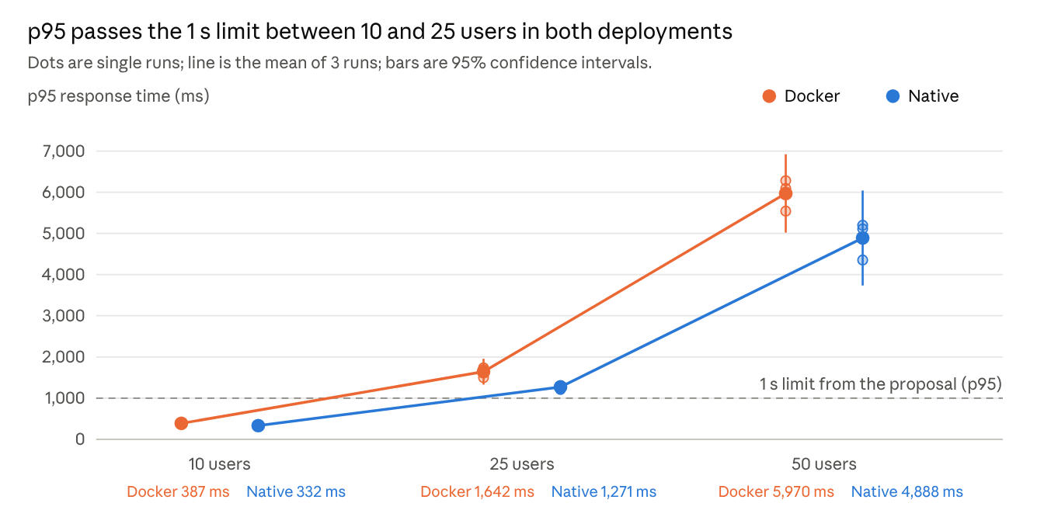
Source: runs.csv, 18 pilot runs; intervals are 95% t-intervals with 2 degrees of freedom
Figure 1: p95 response time vs. concurrent users. Figure 1 shows p95 response time against the number of users. Both deployments stay below 0.4 s at 10 users, rise to about 1.3–1.6 s at 25 users and to roughly 4.4–6.3 s in individual runs at 50 users. At every level, each of the three Docker repetitions had a higher p95 than each of the three native repetitions (for example, 377–394 ms against 323–350 ms at 10 users), but the 95% confidence intervals of the two deployments overlap at all three levels. With three repetitions this is suggestive, not conclusive.
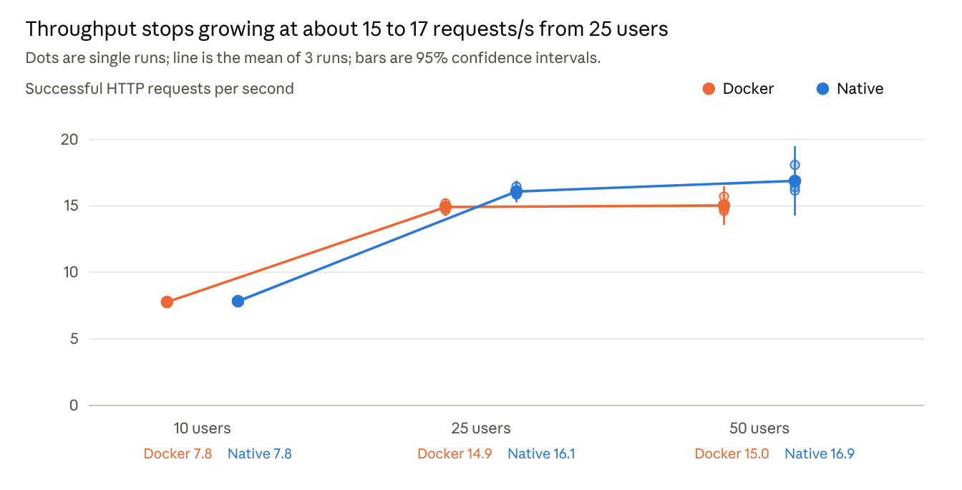
Source: runs.csv, 18 pilot runs; intervals are 95% t-intervals with 2 degrees of freedom
Figure 2: Successful requests/s vs. concurrent users. Figure 2 shows that throughput roughly doubles from about 7.8 requests/s at 10 users to about 15–16 requests/s at 25 users and then barely increases at 50 users, even though p95 more than triples. This flattening together with the CPU values in Figure 3 is consistent with the web VM being saturated; at roughly 1.75 requests per post view, the plateau corresponds to about 9–10 page views per second. The two deployments have the same throughput at 10 users; at 25 users native is higher but the intervals overlap slightly
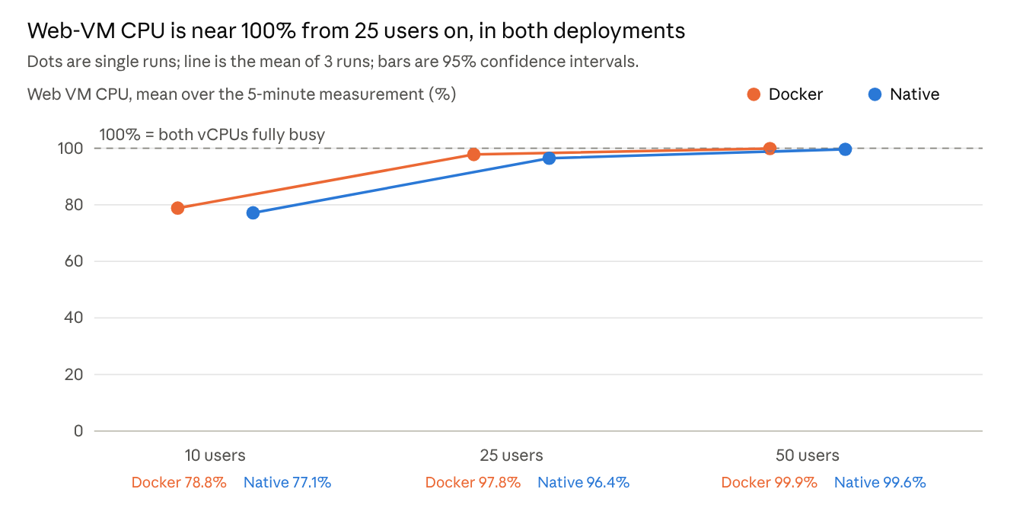
Source: runs.csv, 18 pilot runs; intervals are 95% t-intervals with 2 degrees of freedom
Figure 3: Web-VM CPU vs. concurrent users. Figure 3 shows the mean CPU of the whole web VM during the measurement phase. At 10 users the web VM is already at 77–79% CPU for about 7.8 requests/s, and it reaches 96–98% at 25 users and about 99.6–99.9% at 50. At 10 users, where both deployments serve the same throughput, the Docker deployment used about 1.7 percentage points more CPU (78.8% vs. 77.1%) and the intervals do not overlap. At 25 and 50 users both deployments are close to 100%, so CPU cannot separate them.
Errors and memory. Table 2 shows no HTTP failures and no failed application checks at any level, even when p95 exceeded 5 s. Memory use of the whole web VM grows from about 625 MB at 10 users to about 1.03 GB at 50 users and is the same for both deployments within the spread between repetitions (a standard deviation of at most 7 MB). The container limit of 3 GB was therefore not close to being reached.
Table 2. Error rate, memory and sustained-load criterion (means over 3 runs).
Deployment | Users | HTTP failures (%) | Failed checks (%) | Web memory (MB, SD) | Runs with p95 < 1 s and errors < 1%
Native | 10 | 0.00 | 0.00 | 624 (5) | 3 of 3
Docker | 10 | 0.00 | 0.00 | 629 (4) | 3 of 3
Native | 25 | 0.00 | 0.00 | 755 (7) | 0 of 3
Docker | 25 | 0.00 | 0.00 | 759 (1) | 0 of 3
Native | 50 | 0.00 | 0.00 | 1,034 (6) | 0 of 3
Docker | 50 | 0.00 | 0.00 | 1,032 (4) | 0 of 3
Could the database or load generator have limited the results? No evidence of that appears in the pilot. Across all 18 runs the 95th percentile of the 1-second CPU samples was at most 8.2% on the database VM and 6.4% on the load-generator VM, far below the 80% and 70% levels we use as warning thresholds. The highest single 1-second samples were 45.3% (database) and 32.8% (load generator), both in the first native 10-user run, and were isolated spikes. The bottleneck at 25 and 50 users is therefore the web VM in both deployments.
Summary of what the data supports. Both deployments sustain the 10-user level (p95 under 1 s, no errors) and neither sustains 25 users, so in this setup the sustainable load lies between 10 and 25 users. This brackets the limit of a 2-vCPU web VM, but it is not a measurement of maximum capacity, because only three levels were tested. Native showed lower p95 latency and slightly higher throughput at 25 users than the single container, but the effect is small compared with run-to-run variation and we do not claim a winner.

8. Limitations
- Small sample. Three repetitions at three user levels give wide confidence intervals; the proposal's plan of at least 10 repetitions is not met, and no significance tests have been run.
- Load range. All levels from 25 users up are at or beyond saturation of a 2-vCPU web VM; the proposal's 50–1000 users would not be informative on this VM, and the range between 10 and 25 users, where the transition happens, is not sampled.
- Workload. Read-only browsing only; no search, login or comment writes. Closed workload with 1–3 s think time, so throughput is bounded by the number of users. Each post view counts as two HTTP requests, so p95 includes fast redirect responses and page-level latency is higher than shown.
- Dataset. 10,000 posts but only 2 comments, with repetitive text-only content.
- Configuration differences. Native WordPress could use the whole VM (about 3.9 GiB RAM); the container was limited to 2 vCPUs and 3 GB RAM. Memory use stayed near 1 GB, so the memory limit does not appear to matter here. WordPress was initially 6.6.11 and later observed as 6.9.11 for a reason we have not confirmed; 6.9.11 was validated and used for all runs.
- Environment. Shared cloud tenancy and Ubuntu 18.04 with PHP 7.2.24. VM clocks were not independently verified to be synchronized; windows are matched by timestamp, and a difference of a second or two would not change 5-minute averages.
- Resources. The three VMs use the project's full quota, which limits the VM sizes available for the planned scaling series.
- Other. Container statistics were not collected for the pilot, and startup time has not been measured.

9. Plan Adjustments and Updated Milestones
Changes to the proposal.
- k6 replaces Locust as the load generator.
- Ubuntu 18.04 replaces Ubuntu 22.04.
- Both deployments run one at a time on a single web VM, and there is no separate Nginx VM; k6 sends requests directly to the web VM. The project quota of 8 vCPUs and 8 GB RAM is fully used by the three VMs.
- The pilot covers 10, 25 and 50 users with 3 repetitions instead of 50–1000 users with at least 10 repetitions, and a read-only workload instead of 90/10 and 70/30 mixes.
- The dataset has 10,000 posts and 2 comments instead of 50,000 comments, and it is not restored before each run because the read-only workload does not change it.
- Monitoring uses a custom 1-second whole-VM sampler instead of sar/dstat.
- The Docker container is limited to 2 vCPUs and 3 GB RAM, while native WordPress had the full 2-vCPU VM.
Milestones. Our original timeline is shown first; the revised plan reflects the finding that the web VM saturates between 10 and 25 users and that quota limits larger VMs. The dates in the revised plan are proposed and will be confirmed by the group.
Original dates | Original milestone | Status
Oct 3 – Oct 9 | Provision VMs; install the application in all three deployments | Done for native and single container; multi-container not done
Oct 10 – Oct 16 | Workloads, monitoring scripts, pilot tests | Done (k6, monitoring and analysis scripts, pilot)
Oct 17 – Oct 30 | Main RQ1 and RQ2 experiments; startup trials | Partly done: reduced pilot only
Oct 31 – Nov 5 | Preliminary analysis; midterm report | Done (this report)
Nov 6 – Dec 13 | RQ3 scaling, full statistics, final report | Planned (revised below)

Revised dates | Revised milestone
Nov 6 | Submit midterm report
Nov 7 – Nov 13 | Confirm web VM size and Docker limits; ask about a larger quota for the scaling series; add load levels between 10 and 25 users and more repetitions; test dataset restore
Nov 14 – Nov 20 | Startup-time trials; container statistics; write-mix workloads if restore works
Nov 21 – Dec 1 | Multi-container and scaling runs for RQ3 as resources allow; ANOVA, post-hoc tests and finalized figures
Dec 2 – Dec 10 | Write the final report; publish the repository
Dec 11 – Dec 13 | Final review and submission (due Dec 13)

10. Individual Contributions
The table lists what each member has contributed to the project so far
Member | Contribution
Nathan Mangold | Provisioned the web, database and load VMs and the network. Installed native WordPress (Apache/PHP) with MariaDB on a separate VM; validated the WordPress version, schema and OPcache, seeded 10,000 posts, created backups, wrote the infrastructure notes
Ahron Ramos | Wrote the k6 workload and the run wrapper; ran the smoke tests; defined the 18-run matrix (shuffled with seed 533); wrote the workload and test-procedure description
Aaron Montesines | Wrote the monitoring scripts (1-second sampler on the web, database and load VMs) and the per-run splitting; wrote the analysis scripts, figures and tables and the coverage and bottleneck checks, assembled the report, including the results, limitations and revised milestones
Adrian Co | Installed/configured the docker on the experimental web VM, ran WordPress in a container connected to MariaDB and matched native PHP, web-server and caching settings, set up proxy configurations, verified site and database operations and prepared nginx configuration

